Team Name: ROAR

Members: 1. Riddhish khot

2. Omkar Tondwalkar

3.Abhishek Parekh

Problem Statement: Healthtech

Idea brief:

We create a user interface were in there will be 2 types of registration allowed one for the doctor and other for the patient. We are giving many facilities to patient easy use as compared to doctors’s.

After registration we shall create a login page are doctors as well as the patient are able to login into their account.

There after patient will be asked as which specialized doctor he want to visit in. After the patient enter the type he will be displayed a map where all the doctors of the entered specialized are display where there are practicing currently. Patient can select any option according to distance of travel and current location personal prefrences.And after that the shortest route to that place will be given. This will look somewhat like this

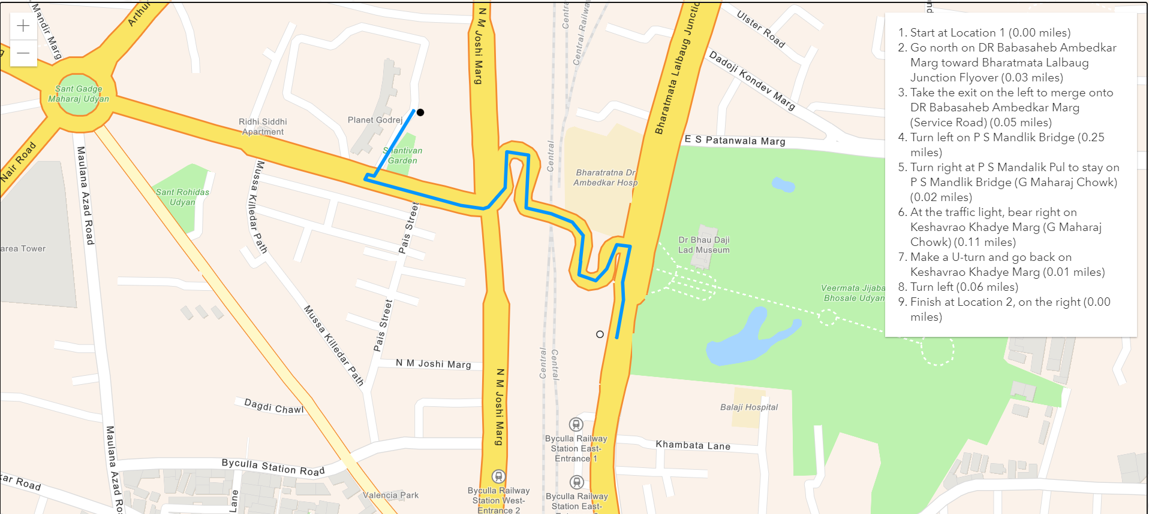

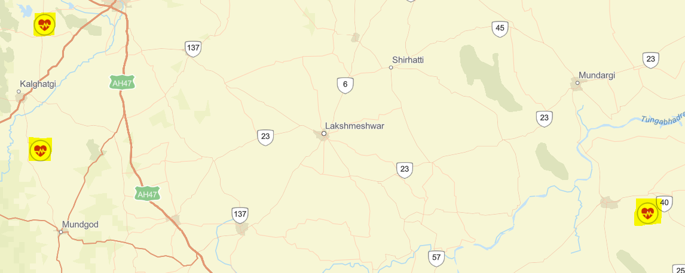

Patient can also directly talk to doctor’s assistant. About any medical emergency or weather the doctors is available at any day or other.

The message exchange interface will have a far better look and experience but as of now it will look as below:

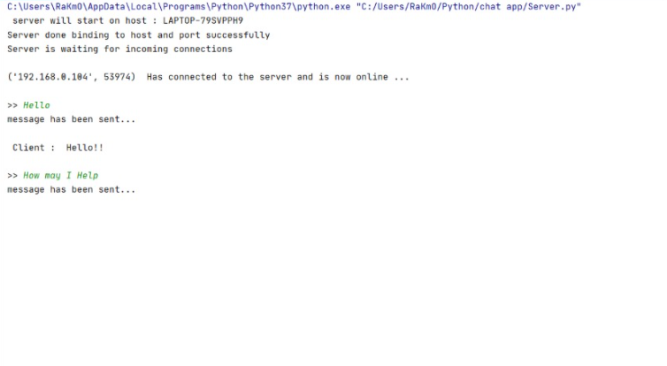

Once Patient visits the doctor. The doctor’s assistant will be able to upload the patient current report. And the patient is able to view current as well as the past reports. And see through his improvements.

Also, patient will be asked if he or she wants a remainder from the assistant for taking medicines at prescribed time give by the doctor. If yes, patient will receive get mail to his account as a remainder about taking his/her medicines.

Tech stack:

1.Flask

3.Python

3.html

4.css

5.database

6.socket.io

7.Arcgis developer map